***MATRICES APPLICATION***

This Matrix Application is intended to solve and clear the basic concepts of Matrix. This Application involves all the basic Matrix properties that are required by the basic learners of Matrices.

We have seen different applications performing mathematical operations and functions, so this is also the part of mathematical application. Here it is a tool for the basic learners by which they can solve, understand and perform the Matrix functions as per their requirement. Below there is a description of complete Matrix application which shows how it is functioning.

As you run the application, it will show u a welcome message, after pressing enter u will have a programmer’s note which will give u the introduction of the application.

Now by pressing Enter you will proceed to the main menu of the application as shown in figure below.

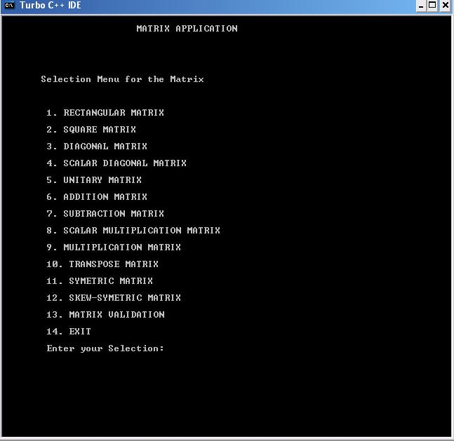

As you can see the menu is providing you variety of options as it is stated above that each property has been defined with an example and except few all can perform their respective function within themselves. Here the user has the complete independence to choose any option as per his/her requirement. Once the users enter their choice, the application will respond according to the choice entered. In most of the above options the user is facilitated to give its own values and achieve the result according to it.

The properties Diagonal Matrix, Scalar Diagonal, Unitary Diagonal, Addition, Subtraction, Multiplication, Scalar multiplication, Symmetric, skew-Symmetric and Matrix Validation will perform the functions, where as the remaining properties like Rectangular, Square and Transpose matrix are not in need to perform functions so they are simply defined but their validation is shown in last property i.e. “Matrix Validation”.

Matrix Validation is the most important option of all in this application as it validates each and every single property and indicates user the correct validation. Below are the two examples explaining the property.

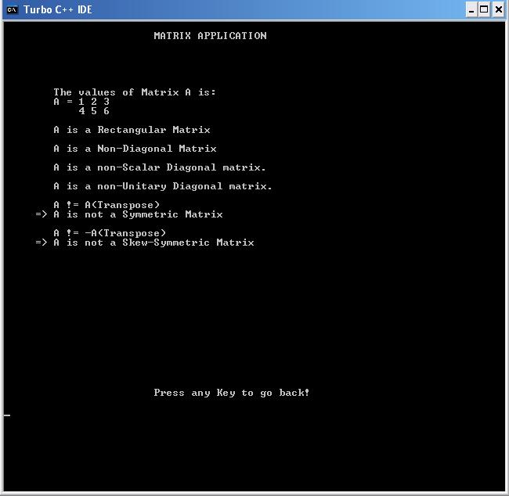

**Example 01**: In this example user has entered a Matrix of its own choice and after validation the property has answered the valid and invalid types of Matrix.

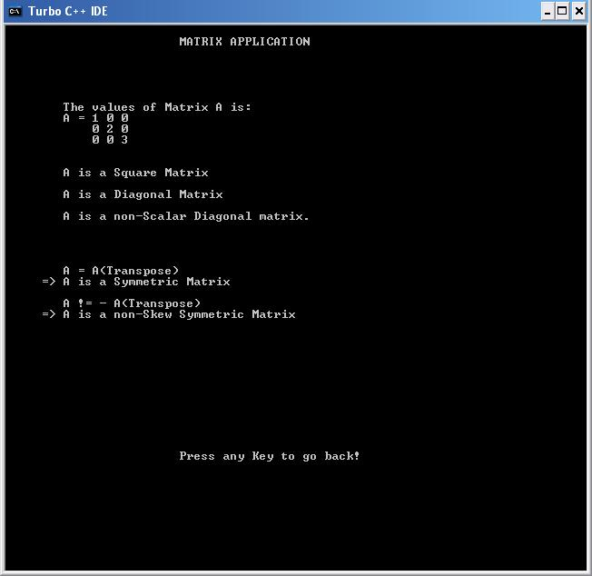

**Example 02**: In this example user has entered a Matrix of its own choice and after validation the property has answered the valid and invalid types of Matrix. But in this example the valid properties are different than in first example, this means the application is designed to work on user’s given Matrix/Matrices.

**Good Luck!**